Iterative Loop of Machine Learning Development
The iterative loop of machine learning development involves several key steps that are repeated until the desired performance is achieved:
- Define System Architecture: This step involves deciding on the overall architecture of the machine learning system, including selecting the appropriate model, choosing hyperparameters, and determining the dataset to be used.
- Implement and Train Model: Once the system architecture is defined, the selected model is implemented and trained using the chosen dataset. Initial training typically yields suboptimal performance.
- Diagnostics and Analysis: Diagnostics are performed to evaluate the performance of the trained model. This includes assessing bias and variance, as well as conducting error analysis to identify areas for improvement.
- Decision Making and Adjustment: Based on insights from the diagnostics, decisions are made to refine the model. This may involve adjusting model architecture, hyperparameters, adding or removing features, or acquiring additional data.
- Iteration: The process iterates, with adjustments made to the system architecture and model based on the results of the diagnostics. Multiple iterations may be required to achieve the desired performance.
Illustration:
- Imagine a scenario where a data scientist is developing a machine learning model to classify images of animals. They initially choose a convolutional neural network (CNN) architecture and train it on a dataset of labeled images. However, upon evaluating the model's performance, they find that it struggles to correctly classify certain types of animals.
- The data scientist conducts bias-variance analysis and error analysis to understand the limitations of the model. They discover that the model has high bias due to its inability to capture complex features in certain animal images.
- Based on this insight, the data scientist decides to increase the depth of the CNN architecture and gather additional training data for underrepresented animal categories.
- The model is then retrained using the updated architecture and dataset, and the process iterates until satisfactory performance is achieved, demonstrating the iterative nature of machine learning development.
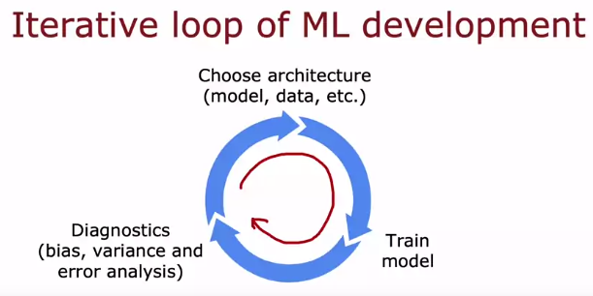

Building an Email Spam Classifier
- Problem Description: Developing a spam classifier involves distinguishing between spam and non-spam emails. Spam emails often contain deceptive content, such as offers for deals, discounts, or fake products.
- Feature Engineering: To build a classifier, features are extracted from the text of the emails. One approach is to create a feature vector representing the presence or absence of the top 10,000 words in the English language. Another approach is to count the frequency of each word in the email.
- Model Selection: Supervised learning algorithms, such as logistic regression or neural networks, can be trained on the extracted features to predict whether an email is spam or not.
- Improvement Strategies: After training the initial model, various strategies can be employed to improve its performance. These include collecting more data, developing more sophisticated features based on email routing or content, and detecting misspellings or deliberate misspellings used by spammers.
- Evaluation and Diagnostics: Diagnostics, such as bias-variance analysis and error analysis, are performed to evaluate the model's performance and identify areas for improvement.
- Iterative Development: The development process involves iterating through various ideas for modifying the model or data based on diagnostic insights. Promising directions are pursued to enhance the classifier's effectiveness.
Illustration:
- Imagine a data scientist developing a spam classifier by extracting features from email text and training a logistic regression model. Initially, the model struggles to distinguish between spam and non-spam emails, resulting in high error rates.
- Diagnostic analyses reveal that the model has high bias, indicating a need for more complex features or additional data. The data scientist considers collecting more data through honeypot projects or refining features based on email routing information.
- Through iterative development cycles, the model is refined based on diagnostic insights, gradually improving its performance in distinguishing between spam and non-spam emails.
This iterative loop of development, coupled with diagnostic analyses, allows for the continuous improvement of the spam classifier, ultimately leading to more accurate and effective detection of spam emails.


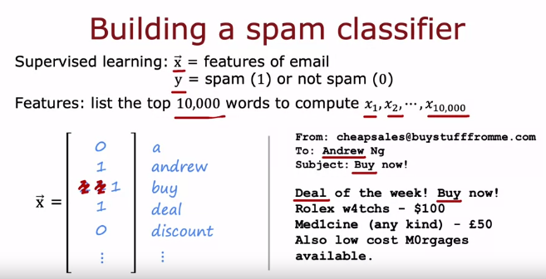
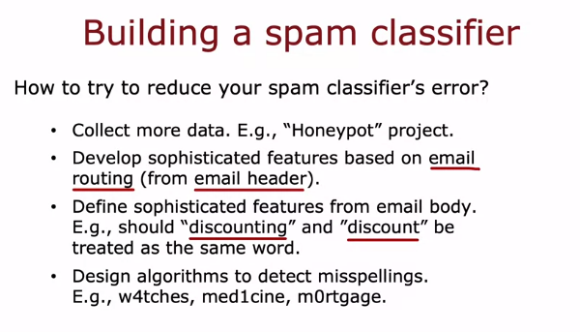

Error Analysis for Model Improvement:
Key Points:
- Error analysis involves manually examining misclassified examples to understand the algorithm's mistakes.
- It helps prioritize improvement efforts by identifying common error patterns.
- It complements bias-variance analysis, giving specific insights beyond high-level trends.
Process:
- Select a representative sample of misclassified examples (e.g., 100 out of 1000).
- Group them into categories based on common features, overlaps are allowed.
- Count examples in each category to assess their relative impact.
Example:
- Spam classifier misclassifies 100 emails.
- Analysis reveals high error rates for:
  - Pharmaceutical spam (21 cases)
  - Phishing emails (18 cases)
  - Embedded image spam (7 cases)
  - Deliberate misspellings (3 cases)
Insights:
- Focus on features and data specifically for pharmaceutical and phishing emails.
- Less effort needed for misspelling detection due to lower impact.
Advantages:
- Uncovers specific error patterns.
- Guides targeted improvement strategies.
- Saves time by focusing on impactful areas.
Limitations:
- Less effective for tasks humans struggle with (e.g., ad click prediction).
- Time-consuming for large datasets.
Tips:
- Prioritize error analysis for interpretable tasks.
- Sample misclassified examples strategically.
- Combine with other diagnostics for comprehensive understanding.
Remember:
- Error analysis is a powerful tool for improving machine learning performance.
- Use it alongside other diagnostics and consider its limitations.
- By understanding your algorithm's mistakes, you can make informed decisions about where to focus your efforts.

Illustration:
- Imagine a data scientist conducting error analysis on a spam classifier. They manually examine a subset of misclassified emails from the cross-validation set and categorize them based on common themes, such as pharmaceutical spam, deliberate misspellings, or phishing attempts.
- After counting the occurrences of each error type, the data scientist identifies pharmaceutical spam and phishing emails as major issues affecting classifier performance, while deliberate misspellings have a lesser impact.
- Armed with these insights, the data scientist decides to focus efforts on collecting more data specific to pharmaceutical spam and phishing emails. They also consider developing new features to improve the classifier's ability to detect these types of spam.
- Error analysis guides decision-making and resource allocation, enabling the data scientist to prioritize improvement strategies that address the most prevalent and impactful error types, ultimately leading to a more effective spam classifier.

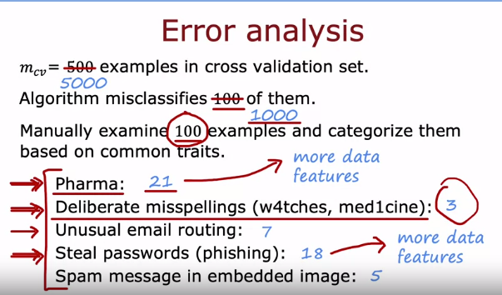

Adding Data : Collecting Targeted Data
- Targeted Data Acquisition: Instead of acquiring more data indiscriminately, focus on obtaining additional examples of specific types where analysis indicates it might improve algorithm performance. For example, if error analysis reveals that pharmaceutical spam is a significant problem, prioritize collecting more data related to pharmaceutical spam rather than gathering more data of all types.
- Efficient Resource Allocation: Targeted data acquisition allows for a more efficient allocation of resources, as it avoids the need to collect large amounts of data across all categories. By focusing efforts on acquiring data in areas where improvement is needed most, resources can be utilized more effectively.
- Leveraging Unlabeled Data: Unlabeled data can be valuable for targeted data acquisition. By having annotators skim through unlabeled data to identify examples relevant to the specific category of interest (e.g., pharmaceutical spam), it's possible to add more data selectively and at a lower cost compared to labeling all data.
- Boosting Algorithm Performance: Adding targeted data can significantly improve algorithm performance by providing more relevant examples for learning. This approach can lead to greater improvements compared to simply adding more data across all categories.
Illustration:
- Imagine a data scientist working on a spam email classifier. Error analysis reveals that the algorithm struggles with identifying pharmaceutical spam. Instead of collecting more data indiscriminately, the data scientist focuses on acquiring additional examples of pharmaceutical spam.
- Leveraging unlabeled email data, annotators skim through the data to identify emails related to pharmaceutical products. These labeled examples are then added to the training dataset, specifically targeting the category where improvement is needed.
- By selectively adding targeted data, the algorithm's performance on identifying pharmaceutical spam improves significantly, demonstrating the effectiveness of targeted data acquisition in enhancing algorithm performance while optimizing resource utilization.
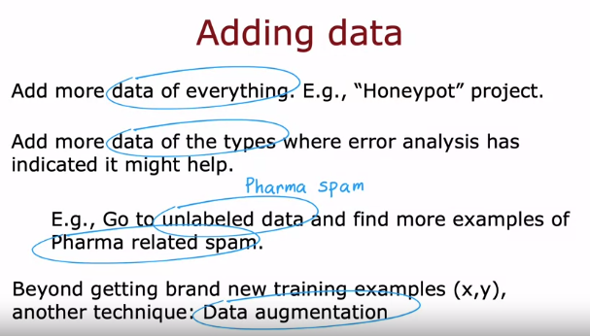

Adding Data: Data Augmentation
Data augmentation is a technique widely used, especially for images and audio data, to increase the size of the training set significantly. It involves creating new training examples by applying various transformations or distortions to existing examples while preserving their labels.

Optical Character Recognition (OCR)
For example, in optical character recognition (OCR) tasks where the goal is to recognize letters from A to Z, data augmentation techniques can include:
- Rotation: Rotating the image slightly.
- Scaling: Enlarging or shrinking the image.
- Contrast Adjustment: Changing the contrast of the image.
- Mirroring: Flipping the image horizontally (applies to some letters).
- Grid Warping: Introducing random warping of a grid overlaid on the image.
These transformations create new examples that are variations of the original image but retain the same label. By augmenting the data with these variations, the learning algorithm is exposed to a more diverse range of inputs, helping it become more robust and better at generalizing patterns.
For instance, in the case of the letter "A," data augmentation could involve rotating the letter slightly, enlarging or shrinking it, adjusting contrast, mirroring it (if applicable), or introducing random distortions through grid warping. These augmented examples provide additional training data, teaching the algorithm to recognize the letter "A" in various forms and orientations.
In summary, data augmentation is a powerful technique for expanding the training dataset and improving the robustness of machine learning models, particularly in image and audio processing tasks.
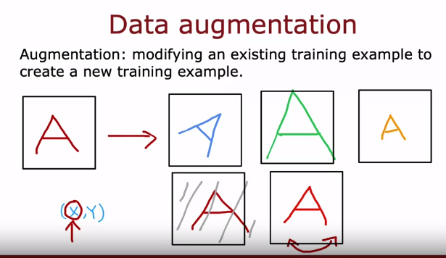
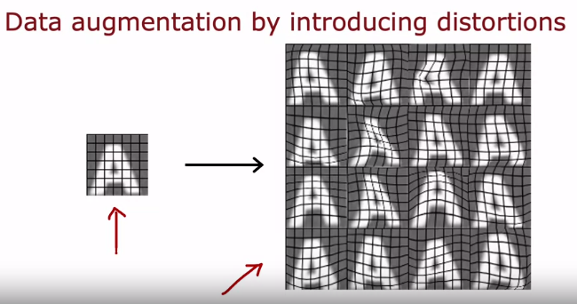

Speech Recognition
Data augmentation is also applicable to speech recognition tasks, such as voice search applications. By introducing variations or distortions to the original audio data, you can create additional training examples that help improve the robustness of the speech recognition model.
For example, let's consider an original audio clip with a clear speech:
"What is today's weather."
To apply data augmentation to speech data, you can incorporate background noise into the original audio. For instance, adding crowd noise to the original audio creates a new example with the same speech but with background noise:
[Audio: "What is today's weather." with crowd noise]
Similarly, adding car noise to the original audio produces another variation:
[Audio: "What is today's weather." with car noise]
Furthermore, simulating poor audio quality, such as a bad cell phone connection, can create additional training examples:
[Audio: "What is today's weather." with poor connection quality]
By generating these variations, you effectively expand the training dataset, providing the model with more diverse inputs and helping it learn to recognize speech in various environmental conditions.
One crucial tip for data augmentation is to ensure that the distortions or changes made to the data are representative of the types of noise or distortions present in the test set. This ensures that the model learns to generalize effectively and performs well in real-world scenarios where different types of background noise or audio distortions may be encountered.
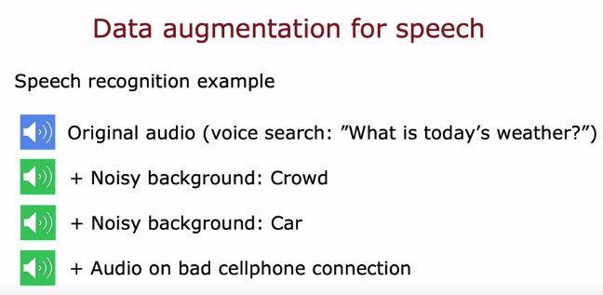
Data augmentation aims to modify or distort existing training examples to create additional data that closely resembles what might be encountered in the test set. This technique is particularly effective when the modifications reflect the real-world variability expected in the test data.
For example, when augmenting images, warping or distorting the original images in ways that still resemble typical examples is beneficial. Adding noise or introducing variations that mimic realistic scenarios, such as different lighting conditions or angles, helps the model generalize better to unseen data.
Similarly, in audio data augmentation, adding background noise or simulating poor connection quality can enhance the model's ability to recognize speech in various environments. However, it's crucial to ensure that the introduced noise or distortions align with the characteristics of the test set.
On the other hand, adding purely random or meaningless noise to the data may not be as helpful, as it might not reflect the patterns present in the test data.
Overall, the goal of data augmentation is to provide the model with diverse training examples that capture the variability of real-world data, ultimately improving its performance on unseen samples.
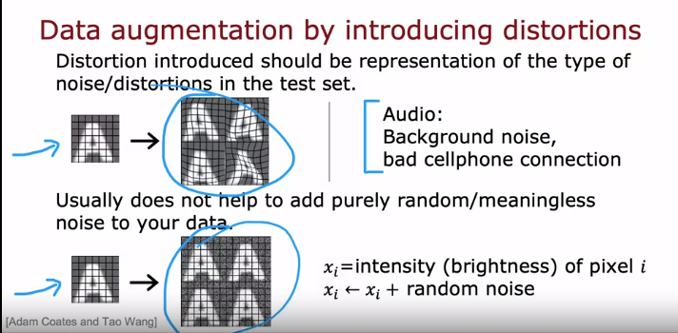

Adding Data: Data Synthesis
Data synthesis involves creating entirely new examples from scratch rather than modifying existing ones. This technique is particularly useful in scenarios where generating new data is more feasible than collecting or modifying existing samples.
For instance, in tasks like photo OCR (Optical Character Recognition), where the goal is to recognize text in images, synthesizing data can be highly effective. By leveraging various fonts and text styles available in computer text editors, researchers can generate synthetic images containing text in different fonts, colors, and contrasts. These synthetic images closely resemble real-world examples and can significantly augment the training data.
While synthesizing realistic data for a specific application may require substantial effort to develop the necessary code, the payoff can be substantial. Synthetic data generation enables the creation of a large volume of training examples, providing a significant boost to the performance of machine learning algorithms.
Although synthetic data generation is commonly used in computer vision tasks, it has seen limited application in other domains. However, its potential for enhancing training datasets makes it a valuable technique across various machine learning applications, including image classification, object detection, and more.

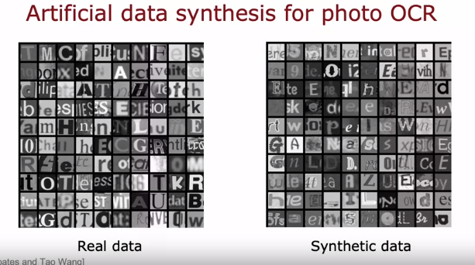

Engineering the data used by your system
In the evolution of machine learning, much attention has historically been placed on refining algorithms, focusing on the model-centric approach. However, with the availability of robust algorithms like linear regression, logistic regression, neural networks, and decision trees, it's increasingly valuable to adopt a data-centric approach.
The data-centric approach involves engineering the data used by your algorithm to improve performance. This can encompass various strategies, including:
- Collecting Targeted Data: Based on error analysis, focus on collecting more data specific to challenging areas identified by the analysis. For instance, if pharmaceutical spam is a significant issue, prioritize collecting more data related to this category.
- Data Augmentation: Enhance the training dataset by applying transformations or distortions to existing data, such as rotating, resizing, or adding noise. This technique is particularly useful for image and audio data.
- Data Synthesis: Generate entirely new examples from scratch, typically using synthetic methods. This can involve creating realistic examples that closely resemble real-world data, effectively expanding the training dataset.
By emphasizing the data-centric approach, you can efficiently improve your learning algorithm's performance without solely relying on algorithmic enhancements. However, there are scenarios where acquiring additional data is challenging or impractical.
In such cases, transfer learning offers a powerful solution. Transfer learning involves leveraging knowledge gained from one task and applying it to another, often unrelated task. By utilizing data from a different domain or task, neural networks can adapt and generalize better to the target application, even with limited available data.
While transfer learning isn't universally applicable, its potential to significantly boost algorithm performance in data-scarce scenarios makes it a valuable tool in machine learning. By understanding and leveraging these techniques, practitioners can effectively enhance their algorithms' capabilities and address real-world challenges efficiently.
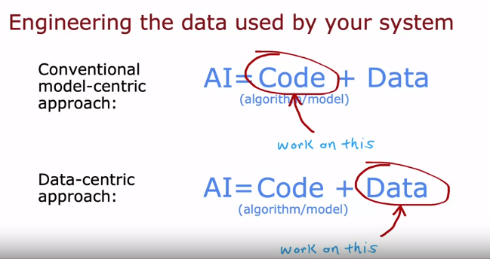

Transfer Learning
Transfer learning is a powerful technique for improving the performance of machine learning models, especially in scenarios where labeled data is limited. Here's how transfer learning works:
- Large Pre-trained Model: Start by obtaining a pre-trained neural network model that has been trained on a large dataset. This dataset often contains diverse images spanning various categories, such as cats, dogs, cars, and people. The pre-trained model has already learned to recognize features across a wide range of classes.
- Adaptation for Target Task: Modify the pre-trained model to suit your specific task, which in this example is recognizing handwritten digits from zero to nine. You achieve this by replacing the original output layer, which is designed to classify images into numerous categories, with a new output layer containing only 10 units corresponding to the digits zero through nine.
- Transfer of Parameters: Retain the parameters (weights and biases) of the earlier layers of the pre-trained model, as they capture general features that are likely to be useful for your target task. However, the parameters of the new output layer need to be initialized randomly or with a small amount of data specific to the target task.
- Fine-tuning Options: There are two main options for fine-tuning the model:
  - Option 1: Freeze the parameters of the earlier layers and only train the parameters of the new output layer using the target task's data.
  - Option 2: Allow all parameters of the model to be updated during training, including those of the earlier layers. In this case, the parameters of the earlier layers are initialized with the pre-trained values and then further adjusted based on the target task's data.
- Supervised Pre-training and Fine-tuning: The process involves two steps: supervised pre-training on the large, diverse dataset and fine-tuning on the target task's specific data. This approach leverages the knowledge gained from the pre-trained model to bootstrap learning on the target task, thereby improving performance even with limited labeled data.
- Availability of Pre-trained Models: Many pre-trained models trained on large datasets are freely available online, allowing researchers and practitioners to easily access them and adapt them to their specific tasks. This facilitates rapid development and deployment of machine learning models with improved performance.
By leveraging transfer learning, practitioners can harness the knowledge embedded in pre-trained models and adapt it to their specific tasks, thereby overcoming data scarcity challenges and achieving better performance in various machine learning applications.
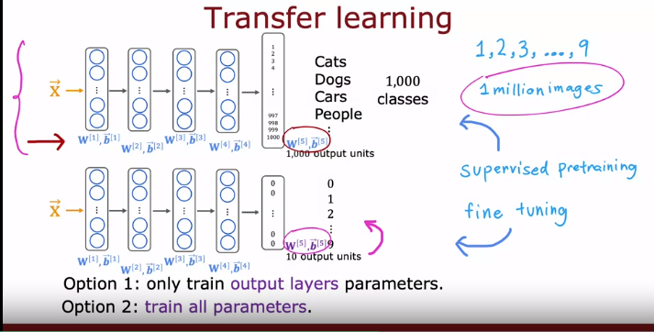

Transfer Learning: Why Does It Work?
Transfer learning works because the features learned by neural networks in earlier layers are often generic and applicable across different tasks. Here's why it's effective:
- Hierarchical Feature Learning: Neural networks learn hierarchical representations of data, starting from low-level features like edges and gradually progressing to higher-level concepts like shapes and objects. During pre-training on a diverse dataset (e.g., images of cats, dogs, cars, and people), the network learns to detect these generic features across various contexts.
- Generalization of Features: By training on diverse images, the neural network becomes adept at identifying common visual patterns such as edges, corners, curves, and basic shapes. These features are not specific to any particular object category but are fundamental building blocks for understanding visual data.
- Feature Reusability: The features learned in the earlier layers of the neural network are transferable and reusable across different tasks. While recognizing cats, dogs, cars, and people may seem unrelated to recognizing handwritten digits, the underlying features learned (e.g., edges, corners) are relevant for both tasks.
- Efficient Knowledge Transfer: Transfer learning leverages the knowledge encoded in pre-trained models and adapts it to new tasks, thereby accelerating learning and improving performance, especially when labeled data for the target task is limited.
- Task-Specific Fine-Tuning: While the generic features learned during pre-training provide a strong foundation, fine-tuning the model on task-specific data allows it to specialize and optimize its performance for the target task. Fine-tuning adjusts the model's parameters to better align with the nuances and intricacies of the new task.
- Compatibility Requirement: It's crucial that the input data type (e.g., images, audio, text) remains consistent between the pre-training and fine-tuning stages. For example, if the pre-training involves images, the fine-tuning data should also consist of images. This ensures that the learned features are relevant and applicable to the target task.
- Application to Different Domains: Transfer learning is not limited to computer vision tasks but can be applied to various domains such as speech recognition and natural language processing. In each case, the pre-training involves data relevant to the specific domain, followed by fine-tuning on task-specific data.
In summary, transfer learning exploits the generic features learned by neural networks during pre-training and adapts them to new tasks, leading to improved performance, especially in scenarios with limited labeled data.

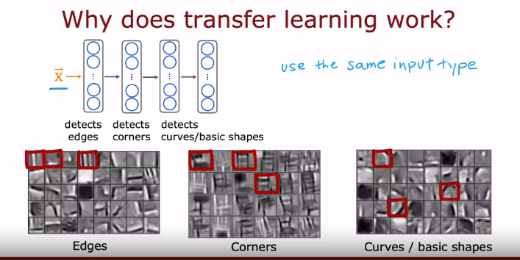

To summarize, here are the two steps for transfer learning:
- Download or Train Pre-trained Neural Network: Obtain a neural network that has been pre-trained on a large dataset with the same input type as your application. This could involve downloading a pre-trained model from the internet, such as one trained on ImageNet for image recognition tasks, or training your own model if necessary. Pre-trained models like GPT-3 or BERTs are examples commonly used for text-related tasks.
- Fine-tune the Network: Further train or fine-tune the pre-trained neural network on your own dataset. This involves adjusting the network's parameters to better suit your specific task or domain. Even with a relatively small dataset, fine-tuning on top of a pre-trained model can yield good results, especially when the dataset for your application is limited.
Key Points:
- Transfer learning isn't a universal solution, but it can be highly effective, particularly when working with small datasets.
- Pre-trained models, shared openly by researchers, enable practitioners to leverage existing knowledge and expertise, accelerating the development of new machine learning applications.
- By joining the machine learning community, individuals can contribute to this collaborative effort and benefit from the collective knowledge and resources available.
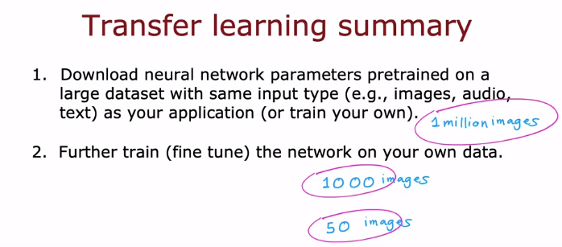

The Full Cycle of a Machine Learning Project:
- Project Scoping:
  - Define the objectives and scope of the machine learning project.
  - Determine what problem you want to solve and what data you need.
- Data Collection:
  - Gather the necessary data to train your machine learning model.
  - Acquire audio, transcripts, or labels required for training.
- Model Training:
  - Train the machine learning model using the collected data.
  - Conduct error analysis and iterate on model improvements.
- Iterative Improvement:
  - Perform bias-variance analysis and error analysis to identify areas for improvement.
  - Collect additional data, if necessary, based on error analysis results.
  - Use techniques like data augmentation to enhance model performance.
- Deployment in Production:
  - Make the trained model available for use by deploying it in a production environment.
  - Continuously monitor the performance of the deployed model.
  - Maintain the system to ensure optimal performance and address any issues that arise.
- Iterative Monitoring and Maintenance:
  - Monitor the deployed model's performance over time.
  - Maintain the system by updating the model or collecting more data as needed.
  - Utilize data from the production deployment to further improve the model.
- Continuous Improvement Loop:
  - Iterate on model training and deployment based on feedback and performance monitoring.
  - Strive for ongoing improvements in model accuracy and effectiveness.
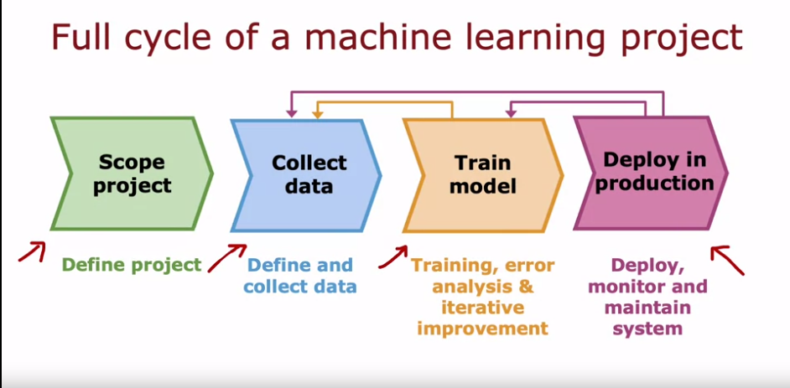

Model Deployment
After training a high-performing machine learning model, such as a speech recognition model, the next step is often to deploy it in a production environment. This typically involves implementing the model in an inference server, which is responsible for making predictions based on input data. For example, if there's a mobile app for a search application, users can interact with the app by speaking into it. The app then makes an API call to send the audio clip to the inference server, which uses the trained model to transcribe the speech and returns the text transcripts to the app.
The deployment process may require significant software engineering effort, depending on the scale of the application. If the application needs to serve millions of users, extensive engineering may be needed to ensure that the inference server can make reliable and efficient predictions without incurring high computational costs. Additionally, software engineering is necessary to manage scaling to accommodate a large number of users.
It's important to log both the input data and the model predictions, assuming user privacy and consent allow for it. This data is valuable for system monitoring, allowing developers to identify shifts in data distribution or decreases in model accuracy over time. Monitoring enables timely retraining of the model and updates to maintain optimal performance.
There's a growing field in machine learning called MLOps, which stands for Machine Learning Operations. MLOps focuses on systematically building, deploying, and maintaining machine learning systems to ensure reliability, scalability, and performance. It involves practices to optimize implementations, monitor system performance, and facilitate updates to the model as needed.
Overall, deploying a machine learning system to millions of users requires careful consideration of software engineering practices and MLOps principles to ensure efficient and reliable operation. While training the model is crucial for performance, deploying and maintaining the system is essential for long-term success.
